Positive Coaching Alliance Online Course Instructions
Partner Name: Webster Girls Softball
Required Course: Coaching for Winning & Life Lessons
Coupon Code: WebsterSoftball25

1. Go to PCA's Online Course Page

Existing Users: If you signed up for a course after 9/1/18, we have transitioned your account to our new platform. To access your account simply click Login and use the "forgot password" function to set a new password.

If you are new to PCA’s Online Courses – or registered for your last course before September 1, 2018, Please Click Sign Up
2. Once registered or signed in – you will be taken to your PCA Online Course Dashboard:
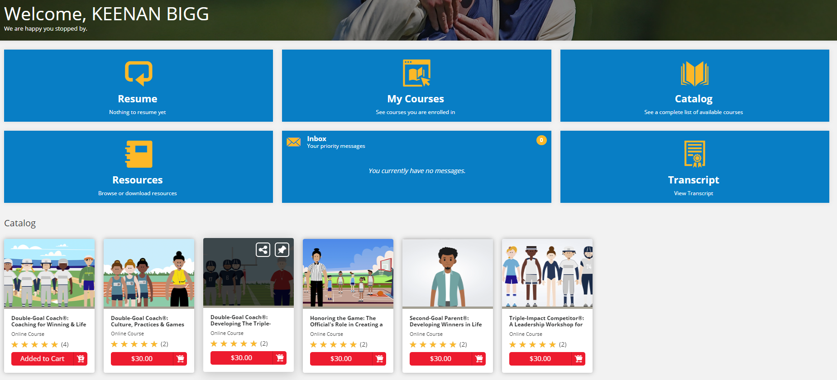

Visit the Catalog at the bottom of the page, and click the $30.00 – Add to Cart button underneath the course you wish to complete.

3. In the upper right corner, click the shopping cart icon and View Shopping Cart

4. After confirming you’ve selected the correct course, Enter your Coupon Code listed above and click Apply and once discount is applied, click Proceed to Checkout

5.Complete the shipping information (required) and payment process (if necessary) and click on View Course to begin!

